Forty-third Annual General Meeting

Tuesday 6 June 2023 at 6.30pm in Room G03 at Aston University, School of Optometry, Vision Sciences Building, Birmingham, B4 7ET and online.

The AGM is running alongside the 2023 President’s Medal Lecture. Please register for the AGM and lecture at: AGM & President's Medal Lecture: in person - College of Optometrists (college-optometrists.org).

Notice is hereby given that the forty-third Annual General Meeting of the College of Optometrists (‘the College’) will be held at Aston University, School of Optometry, Vision Sciences Building, Birmingham, B4 7ET at 6.30pm and by video conference for the purpose of transacting the ordinary business of the College noted below.

The documents relating to the AGM are available at college-optometrists.org/annual-reports.

- President’s address.

- To remember deceased Fellows and members.

Ordinary business

- To receive the Treasurer’s report and the Accounts of the College together with the reports of the Board of Trustees and the auditors for the year ended 30 September 2022 pursuant to Bye-law 57 of the College’s Bye-laws.

- To receive a report from the Chief Executive.

- To receive a report on the results of the election of members to Council and the Board of Trustees.

- Any Other Business.

Dated: 28 April 2022
Registered office: 42 Craven Street, London, WC2N 5NG

By Order of the Board
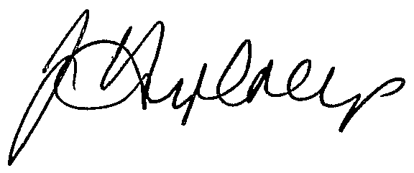
Ian Humphreys
Chief Executive

