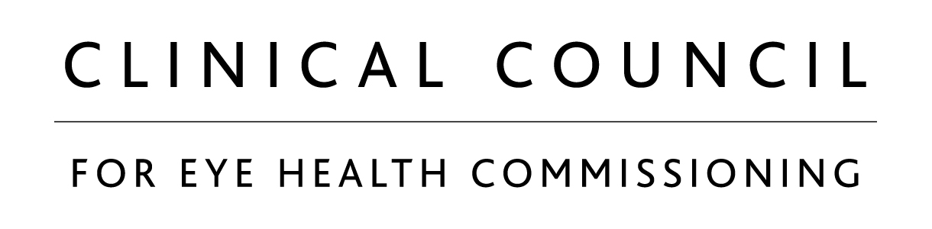

**Clinical Council for Eye Health Commissioning**

**Terms of Reference (revised November 2022)**

**Purpose**

To provide evidence-based national clinical leadership, advice and guidance to policy-makers and those commissioning and providing eye health and care services in England.

**Role**

To bring together the leading patient and professional bodies involved in eye health, the Council’s role is strategic and advisory, focusing on priority issues related to the commissioning of eye health, social care and public health services. The Clinical Council’s advice is based on the best evidence available and independent of any professional or commercial interests.

**Main functions**

To draw on the expertise of its members, singularly and collectively to:

* provide national, representative clinical leadership and advocacy for eye health and eye care;
* provide evidence-based advice and guidance to:
  + inform NHS policy and strategies for planning, commissioning and provision of eye health and care services
  + highlight systemic problems in the delivery of eye health and care services and priorities for solutions to address them
* work in partnership with commissioners, providers, government and NHS organisations, local authorities and patients to drive improvements in delivery and organisation of eye health and eye care services.

**Membership**

The Clinical Council will consist of representatives from the following Member Organisations:

* The Royal College of Ophthalmologists – 4 nominees
* The College of Optometrists – 3 nominees
* Local Optical Committee Support Unit (LOCSU) – 1 nominee
* British and Irish Orthoptic Society – 1 nominee
* Royal College of General Practitioners – 1 nominee
* Royal College of Nursing (Ophthalmic Section) – 1 nominee
* Association of British Dispensing Opticians – 1 nominee
* Royal National Institute of Blind People – 1 nominee
* Faculty of Public Health – 1 nominee
* Association of Directors of Adult Social Services – 1 nominee
* Glaucoma UK – 1 nominee
* Macular Society – 1 nominee
* Association of Optometrists (AOP) – 1 nominee
* Federation of Optometrists and Dispensing Opticians (FODO) – 1 nominee

Attendees: NHS England – 3 representatives

The Clinical Council may co-opt members with additional expertise as required for specific tasks or contributions to deliver its main functions.

**Term of Office**

Clinical Council members are expected to serve for a period of two years, renewable at the discretion of the Member organisation, but with the expectation that they would plan to refresh their representation on Council after a maximum of three terms.

Each member organisation sets its own internal processes for selecting nominees who are able to contribute to the main functions of the Clinical Council.

**Chair**

Clinical Council members are eligible for election after serving one term (2 years). The Chair is elected by the Clinical Council members. The Chair shall serve for a term of two years which is renewable once, subject to further nomination, for a maximum of two terms, or subject to extraordinary or exceptional circumstances as below.

**Vice-Chair**

Clinical Council members are eligible for election after serving one term (2 years). The Vice-Chair is elected by the Clinical Council members. The Vice-Chair shall serve for a two-year term, which is renewable once, subject to further nomination, for a maximum of two terms, or subject to extraordinary or exceptional circumstances as below.

**Chair and Vice-Chair: Extraordinary and exceptional circumstances**

In extraordinary or exceptional circumstances, one or more Member Organisation(s) may propose a motion (before or during a meeting of the CCEHC) to extend the mandates of the current Chair and/or Vice-Chair for a maximum of one year without an election, including a rationale for this proposal.

If the Chair and/or the Vice-Chair agree to have their mandate extended, they will withdraw themselves from the discussion of the motion. If needed, the Secretariat will hold an exceptional meeting with appropriate notice and information to discuss the motion.

Members’ representatives (excluding the Chair and Vice-Chair as applicable) will be asked to vote for or against the motion via an online survey, which will be administered by the Secretariat.  The voting period will be no longer than 5 working days and the representatives of each Membership Organisation will each have one vote.  The final decision will be taken by simple majority. The result will be announced by the Secretariat by email and will be recorded for transparency.

If the result is tied, the Council will maintain the status quo and continue to run the election process.

**Co-option of Chair or Vice Chair**

If, after a call for nominations, there are no nominations for Chair and/or Vice-Chair, the Council may co-opt an individual to either role for a maximum of one year on the basis of a simple majority vote if necessary.

One or more Member Organisations may propose a co-option who will either already represent or be eligible to represent one of the Member Organisations. It is not necessary for them to have previously served a two-year term of office on the Council.

Members’ representatives will be asked to vote via an online survey, which will be administered by the Secretariat. The voting period will be no longer than 5 working days and each representative will have one vote. The final decision will be taken by simple majority. The result will be announced immediately by the Secretariat by email and will be recorded for transparency.

If the result is tied, a second round of voting will take place between the tied candidates. If there is still a tie, the co-option will not have been approved.

**Working methods**

The Clinical Council will operate through evidence-based consensus to ensure that its advice reflects the combined expertise of its constituent bodies.

The Clinical Council will endeavour to arrive at all decisions by unanimous agreement but when this is not possible, the view of the majority will prevail and will be adhered to by all members. Where differences arise, these shall be recorded in the minutes of meetings for transparency.

The Clinical Council shall meet a minimum of twice a year.

**Governance and Accountability**

Members of the Clinical Council are representatives of the body or sector which nominates them and responsible for reporting and accountability to that body/sector.

Member organisations to provide details on:

* Their internal arrangements for receiving and acting on reports from their representatives to the Clinical Council
* How Clinical Council functions, activity and outputs are incorporated into their operational processes, and disseminated to their professional membership.

**Secretariat**

The Royal College of Ophthalmologists and College of Optometrists to provide the secretariat for the Clinical Council by agreement between the two organisations.

**Managing conflicts of interest**

The Clinical Council will publish a conflicts of interest policy applying to both individuals and organisations. A register of members’ interests to be maintained with a requirement for declarations of interest to be flagged prior to discussion on conflicted items.

**Outputs**

Members will agree a rolling twelve-month work programme of activities and desired outcomes, and progress will be reported on annually. In addition, the Clinical Council will respond to relevant issues as they arise or if asked to do so by NHS England, other NHS bodies, or the Department of Health and Social Care.

**Fees and Expenses**

Members are not paid fees. Expenses will be claimed from the nominating organisation in accordance with their own protocols in force at the time.

**Review**

These terms of Reference shall be reviewed in one year. Agreement on these being subject to the decision-making rules set out above.